***Chemistry***

**8: Advanced Theories of Covalent Bonding**

**8.3: Multiple Bonds**

23. The bond energy of a C–C single bond averages 347 kJ mol–1; that of a  triple bond averages 839 kJ mol–1. Explain why the triple bond is not three times as strong as a single bond.

Solution

A triple bond consists of one σ bond and two π bonds. A σ bond is stronger than a π bond due to greater overlap.

25. A useful solvent that will dissolve salts as well as organic compounds is the compound acetonitrile, H3CCN. It is present in paint strippers.

(a) Write the Lewis structure for acetonitrile, and indicate the direction of the dipole moment in the molecule.

(b) Identify the hybrid orbitals used by the carbon atoms in the molecule to form σ bonds.

(c) Describe the atomic orbitals that form the π bonds in the molecule. Note that it is not necessary to hybridize the nitrogen atom.

Solution

(a)



(b) The terminal carbon atom uses *sp*3 hybrid orbitals, while the central carbon atom is *sp* hybridized. The terminal carbon atom forms four σ bonds (three to the hydrogen atoms and one to the carbon) while the central carbon forms two σ bond (one to carbon and one to nitrogen). (c) Each of the two πbonds is formed by overlap of a 2*p* orbital on carbon and a nitrogen 2*p* orbital.

27. Identify the hybridization of the central atom in each of the following molecules and ions that contain multiple bonds:

(a) ClNO (N is the central atom)

(b) CS2

(c) Cl2CO (C is the central atom)

(d) Cl2SO (S is the central atom)

(e) SO2F2 (S is the central atom)

(f) XeO2F2 (Xe is the central atom)

(g)  (Cl is the central atom)

Solution

(a) *sp*2; (b) *sp*; (c) *sp*2; (d) *sp*3; (e) *sp*3; (f) *sp*3*d*; (g) *sp*3

29. For each of the following molecules, indicate the hybridization requested and whether or not the electrons will be delocalized:

(a) ozone (O3) central O hybridization

(b) carbon dioxide (CO2) central C hybridization

(c) nitrogen dioxide (NO2) central N hybridization

(d) phosphateion  central P hybridization

Solution

(a) *sp*2, delocalized



(b) *sp*, localized



(c) *sp*2, delocalized



(d) *sp*3, delocalized

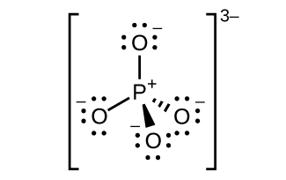

31. Draw the orbital diagram for carbon in CO2 showing how many carbon atom electrons are in each orbital.

Solution

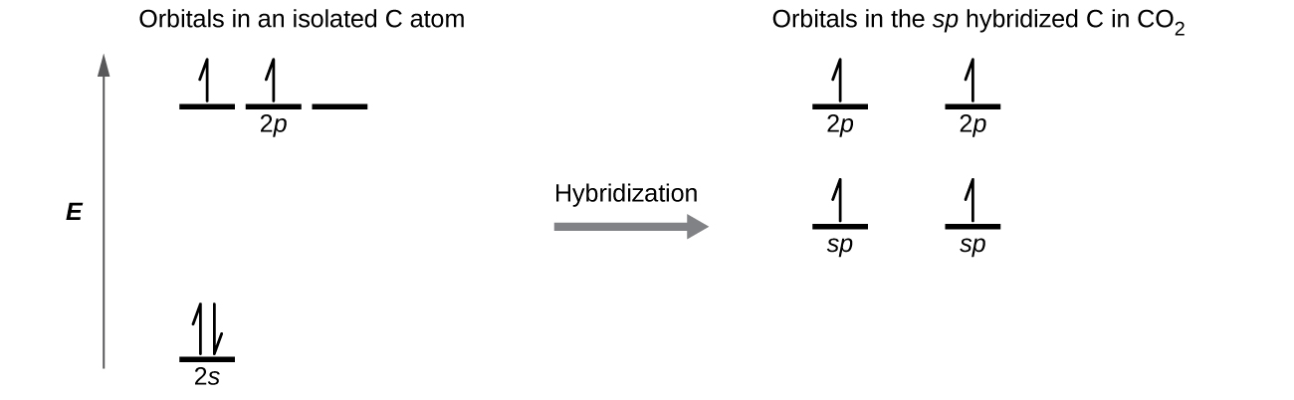

Each of the four electrons is in a separate orbital and overlaps with an electron on an oxygen atom.

This resource file is copyright 2015, Rice University. All Rights Reserved.